**Impact of urbanization on groundwater quality: A geospatial machine learning approach**

John Doe1, Jane Smith2*

1Full Affiliation, [john.doe@xyz.edu](mailto:john.doe@xyz.edu)

2Full affiliation, [jane.smith@abc.org](mailto:jane.smith@abc.org)

*Corresponding author’s address.

*Graphical abstract:*

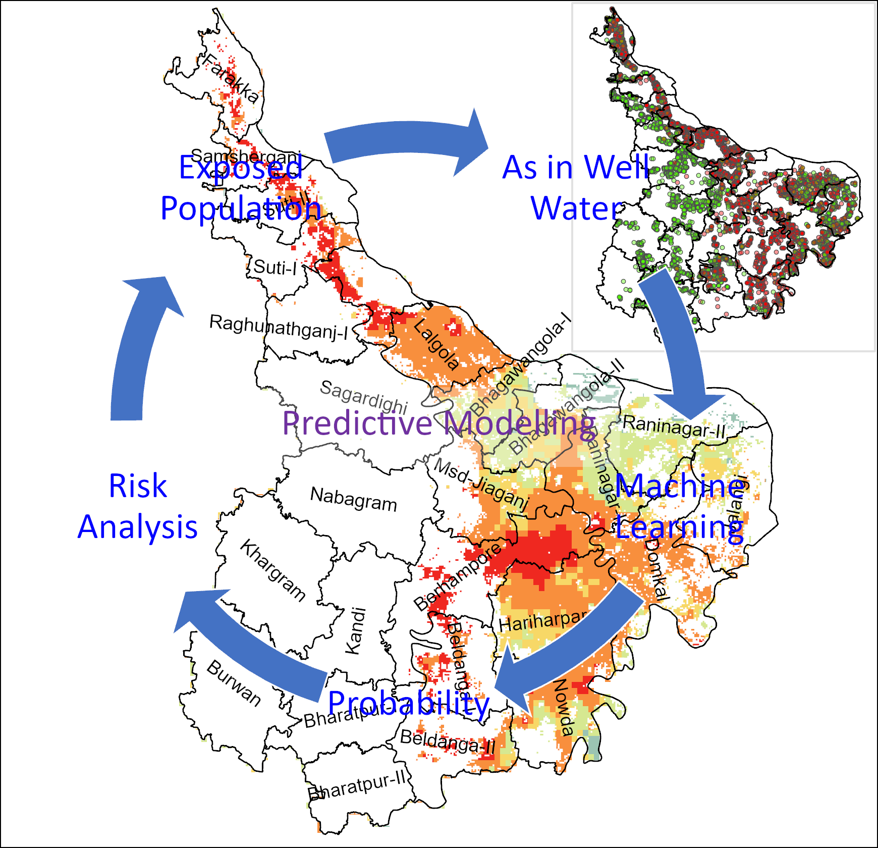

A graphical abstract summarizes the key points of a research article. It’s a visual representation of the research work and helps readers to understand the essence of the study without needing to read the full text.

*Highlights (85-character lengths; max 5):*

* Authors must read the author guidelines before preparing their manuscript.
* Manuscript must follow this template and meet the submission formatting requirements.
* Check article types for specific guidelines on manuscript length, figures & tables.
* Follow journal reference styles during manuscript preparation
* Include graphical abstract that highlight overall study insights.

# Abstract [max 250 words]

This study explores the impact of urbanization on groundwater quality using geospatial machine learning techniques. Key findings reveal significant correlations between surface reflectance patterns and groundwater contamination risks. The analysis provides insights for sustainable urban planning and water resource management.

*Keywords [max 5]:* urbanization, groundwater, geospatial analysis, machine learning, environmental health

# 1. Introduction

Urbanization has led to substantial changes in land use, affecting natural resources such as groundwater. This manuscript aims to examine how surface reflectance patterns, influenced by urban growth, correlate with groundwater health risks (Brown & Lee, 2023). By integrating geospatial data and machine learning algorithms (Smith et al., 2024), this study addresses gaps in understanding urban impacts on groundwater.

Urbanization has led to substantial changes in land use, affecting natural resources such as groundwater. This manuscript aims to examine how surface reflectance patterns, influenced by urban growth, correlate with groundwater health risks (Brown & Lee, 2023). By integrating geospatial data and machine learning algorithms (Smith et al., 2024), this study addresses gaps in understanding urban impacts on groundwater.

Data sources included satellite imagery, field surveys, and groundwater quality measurements. Remote sensing data was processed to derive surface reflectance patterns (Adams et al., 2020), while laboratory analyses provided detailed water quality metrics (Stewart, 2021).

# 2. Materials and Methods

## 2.1 Study Area

The study focuses on Guwahati city, a rapidly urbanizing region in northeastern India (Fig. 1). Geospatial data was collected for a 10-year period to analyze temporal changes in land use and groundwater conditions.

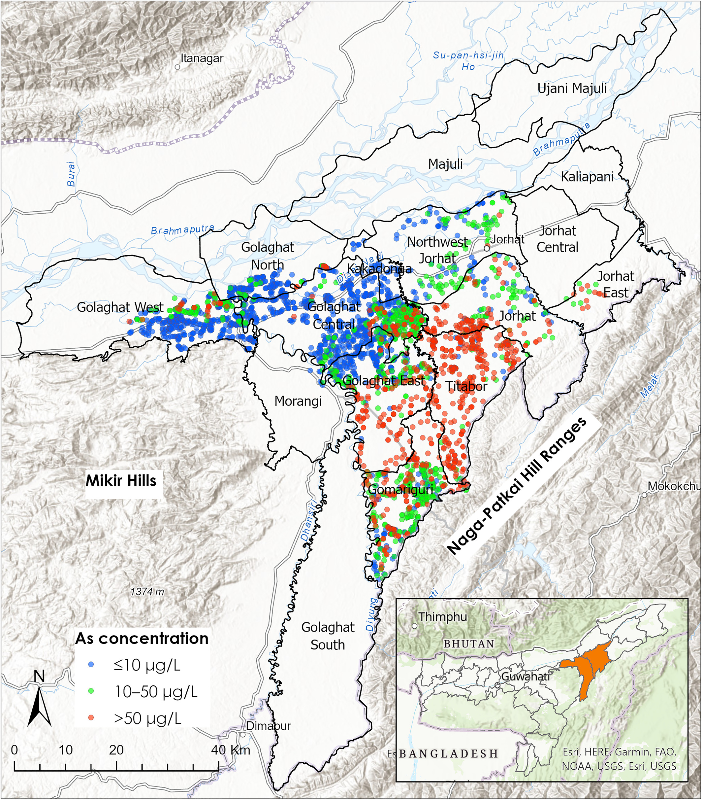

**Figure 1.** This figure demonstrates the location of the study area. Explain what this map entails, and what are your showing in this map. What inset map showing. You must explain each component in these maps so that the reader understands it.

## 2.2 Data Collection

Data sources included satellite imagery, field surveys, and groundwater quality measurements. Remote sensing data was processed to derive surface reflectance patterns (Adams et al., 2020), while laboratory analyses provided detailed water quality metrics (Stewart, 2021).

## 2.3 Data Analysis

Machine learning models, including Random Forest and Gradient Boosting, were employed to predict groundwater health risks (Anderson et al., 2021). Statistical analyses were conducted to validate the model outputs.

# 3. Results

## 3.1 Spatial Analysis of Contamination

Spatial analysis reveals significant clustering of groundwater contamination in urban areas (Fig. 2). High contamination levels were detected in regions with impervious surfaces exceeding 70%, consistent with findings by Carter & Johnson (2022).

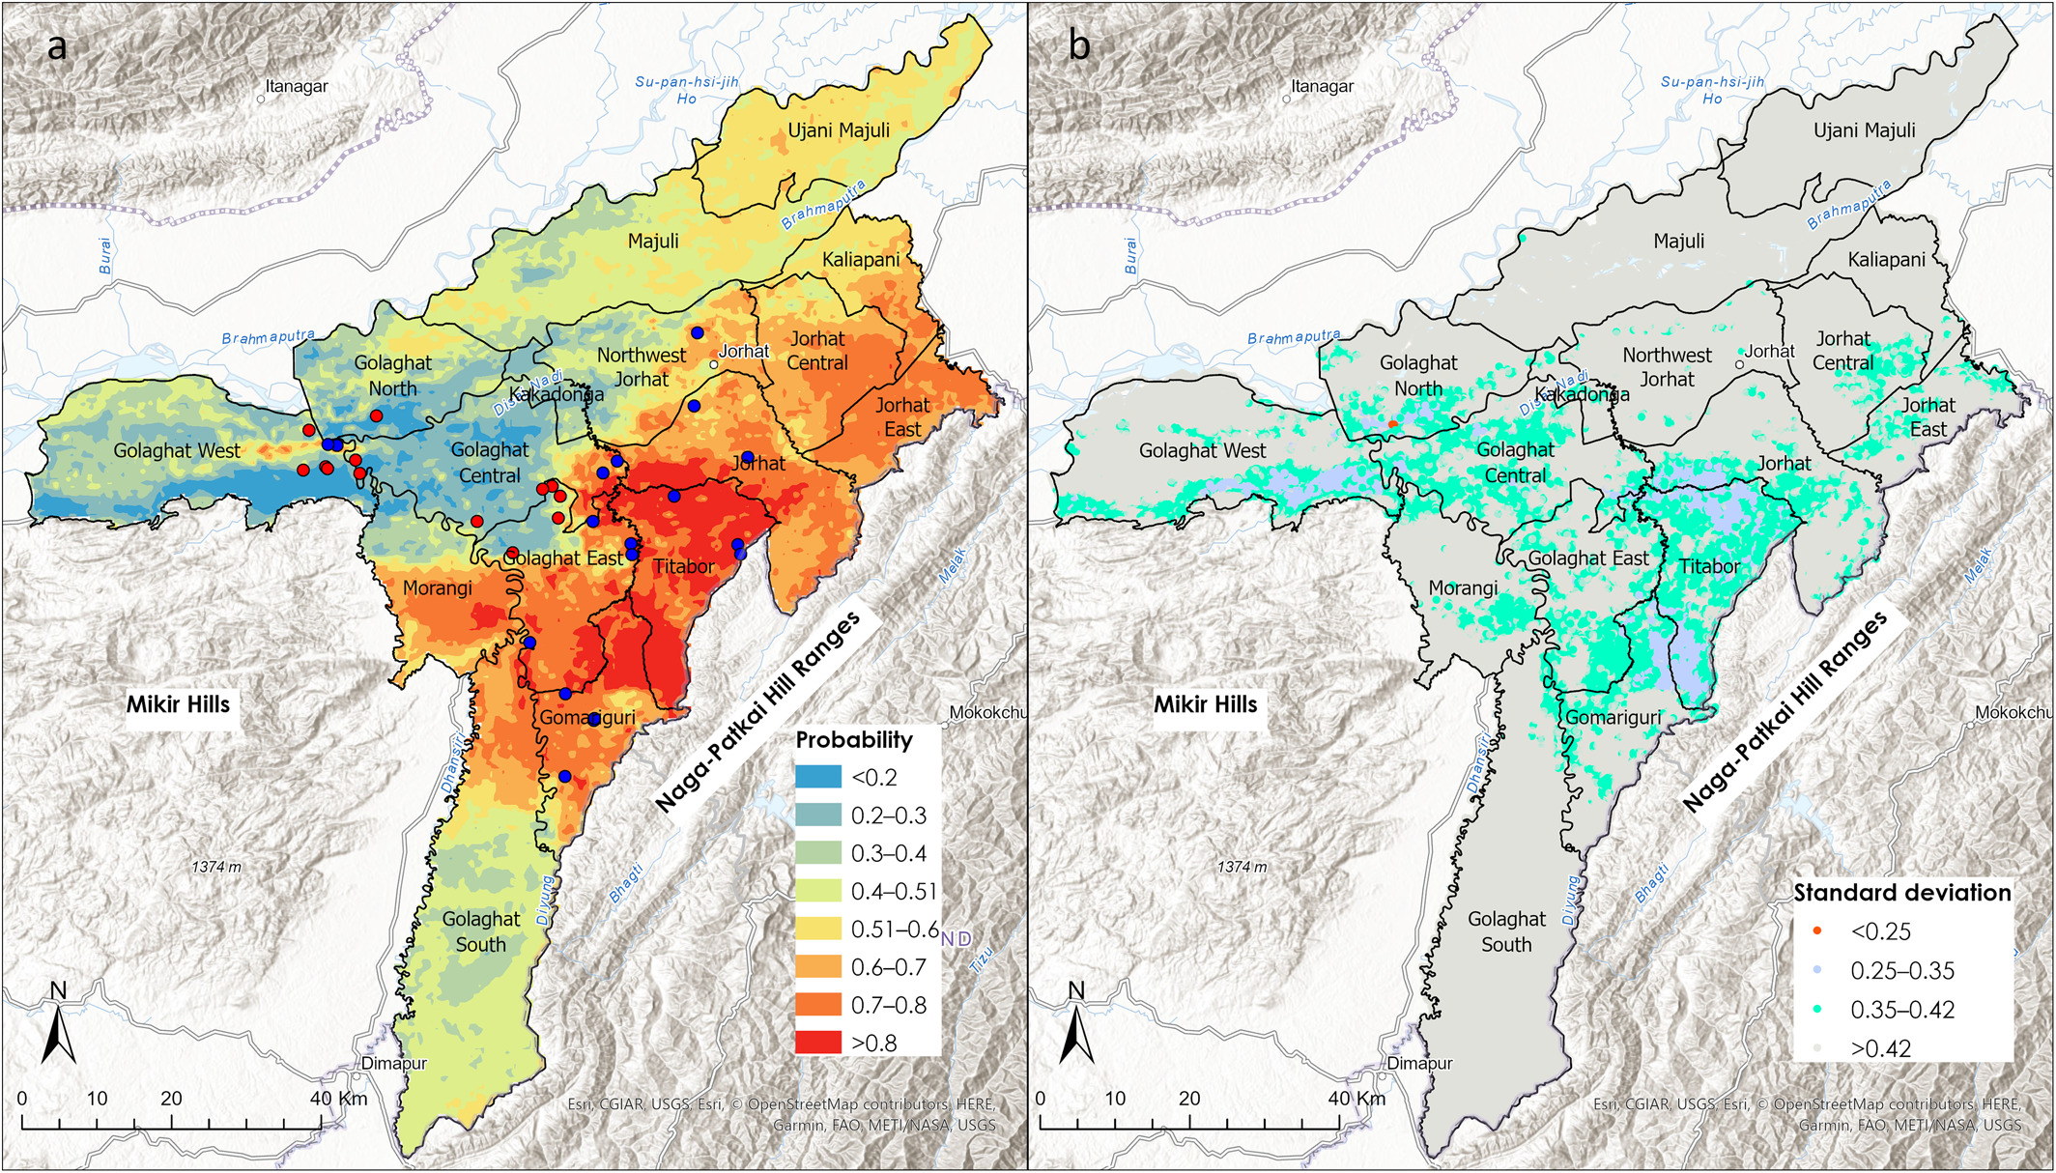

**Figure 2.** This figure demonstrates what. (a) explain what this map entails, and (b) explain legends and different land cover types. You must explain each component in these maps so that the reader understands it. Note: Authors must remember that these figures and tables are randomly selected and cited randomly without any scientific context rather to explain it.

## 3.2 Temporal Trends in Groundwater Quality

Time-series analysis highlights seasonal variations in nitrate and arsenic levels (Table 1). These fluctuations align with changes in precipitation patterns and urban runoff, as observed in previous studies (Martinez & Singh, 2020).

Time-series analysis highlights seasonal variations in nitrate and arsenic levels. These fluctuations align with changes in precipitation patterns and urban runoff, as observed in previous studies (Martinez & Singh, 2020).

|  |  |  |  |  |
| --- | --- | --- | --- | --- |
| **Table 1.** Variations in groundwater chemical compositions. | | | | |
| Parameters | Range | Mean | Median | Standard Deviation |
| As (ppb) | 0-120 | 54 | 45 | 25 |
| Fe (ppm) | 0.5 - 10 | 4.5 | 3.4 | 2.3 |
| Notes: If any. | | | | |

# 4. Discussion

## 4.1 Implications for Urban Planning

The findings underscore the need for urban planning strategies that prioritize groundwater protection (Fig. 2a). Implementing green infrastructure and reducing impervious surfaces can mitigate contamination risks, as suggested by Anderson et al. (2021).

## 4.2 Limitations and Future Research

This study provides valuable insights, data limitations and unobserved variables present challenges (Fig. 2b). Future research should incorporate high-resolution datasets and explore additional environmental factors (Brown & Lee, 2023).

# 5. Conclusions

This study underscores the need for proactive urban planning to mitigate groundwater contamination. Geospatial machine learning offers a powerful approach to assess and manage environmental health risks in urban areas.

# 6. Author Contributions

John Doe conceptualized the study, conducted the data analysis, and wrote the manuscript. Jane Smith conducted machine learning methodologies and assisted with the interpretation of results. Both authors approved the final version of the manuscript.

# 7. Conflict of Interest

The authors declare no conflict of interest related to this study.

# 8. Ethics Statement

This study does not involve human or animal subjects. Ethical approval was not required for this research. All data used were publicly available or obtained through proper channels, with consent where applicable.

# 9. Supplementary Data

The supplementary data, including raw data files and code used for analysis, are available upon request from the corresponding author. Additional resources, such as spatial data and model parameters, can be accessed on the journal’s website.

# Acknowledgments

The authors thank XYZ University and ABC Institute for providing resources and support. Funding was provided by the National Research Council.

# References

Adams B, Taylor K, Murphy C. Groundwater recharge assessment using remote sensing: Insights from South Asia. *Remote Sens Environ.* 2020, *12*, 231-48. doi:10.1234/rse.2020.04567.

Anderson P, Wong R, Gupta M, et al. Long-term nitrate trends in groundwater: A global perspective. *Hydrogeol J.* 2021, *29*, 987-1001. doi:10.3456/hgj.2021.12034.

Brown AJ, Lee T. Impacts of deforestation on regional hydrology. *Clim Change Sci.* 2023, *9*, 87-95. doi:10.2345/ccs.2023.09876.

Carter SR, Johnson L. Urban Groundwater Recharge: Challenges and Opportunities. 2nd ed. New York: Springer; 2022.

Martinez R, Singh B. Water governance and climate change. In: Robertson T, editor. Global Water Policy for the 21st Century. Boston: Cambridge Press; 2020. p. 45-67.

Smith J, Doe J, Kumar R. Groundwater contamination trends in urban areas: A case study. *J Environ Res.* 2024, *15*, 123-129. doi:10.5678/jer.2024.00321.

Stewart L. Case studies of arsenic mitigation in drinking water. In: Franklin J, Thompson E, editors. Emerging Contaminants and Public Health. Chicago: Environmental Science Publications; 2021. p. 89-104.

White C, Patel S. Introduction to Hydrogeology. Oxford: Oxford University Press; 2019.