**A step-by-step guide to manuscript submission:**

**Step 1:** Go to the publisher’s website at: <https://journals.enviromindsolutions.com/>. Scroll down the page to find the list of active of journals.

Click on the active journal – *Journal of Environmental Science, Health & Sustainability*. Once you click the link, you will be directed to a page containing all relevant journal information, such as details about the journal, the editorial team, author guidelines, and other pertinent information regarding article publication and editorial policies.

**Step 2:** Register as a user and/or log in using your credentials. To register, complete the form (on the right) and create a login account. Don’t worry if you don’t receive an email; a confirmation will appear on the webpage. Simply follow the instructions. If you happen to forget your password, you can retrieve it by clicking ‘forgot your password’.

You’re ready to log in once you’ve registered.

**Step 3.** After logging in, you can toggle between different active journals at the top-left corner of the webpage. Select the desired journal to proceed with your submission. Use ‘New Submission’ tab to begin submission.

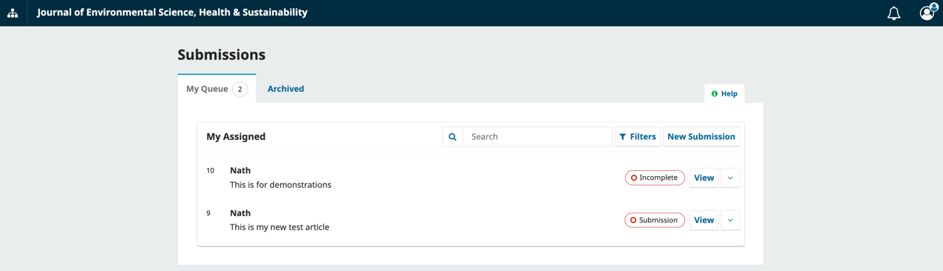

**Step 4.** Read the ‘make a submission’ documentation and follow the instructions to begin your submission (click). You must provide your submission title and select the article type (section). Be sure to read the submission checklist thoroughly.

**Step 5.** Complete the details on this page (including a maximum of five keywords and an abstract of less than 250 words). Once satisfied with that continue to upload files.

Updates: On the same form a new field (“References”) is included. In the text box enter each reference on a new line so that they can be extracted and recorded separately.

**Step 6.** On this page you are required to upload your submission files. You must include a cover letter and the full manuscript (which includes manuscript text, figure, & tables) as a single combined file. If you are submitting additional documents, click ‘other’ to choose the specific type of file. Afterward, proceed to the next step.

**Step 7.** Add the list of contributors (if there are multiple authors) and complete their details.

**Step 8.** This step is essential for the metadata. Please read it thoroughly.

**Step 9.** This step is for reviewing the information included in the submission. Check for any missing information. For example, the screenshot shows number of errors (intentionally added to highlight how mistakes are displayed) that must be corrected before proceeding to the final submission.

**Step 10.** The final step is to confirm the submission details, including copyright information and the author’s responsibilities. If the submission is complete, you can proceed by clicking ‘submit’. Once submitted, the author should receive an email confirmation from the journal confirming the successful submission.

Thank you very much for considering our journal for your submission.